InnoEnergy Hub Partnership Proposal Template
Instructions

The partnership proposal template is designed to assist in prompting and structuring partnership proposals prior to submission for analysis and decision-making.

In proposing your partnership, your overall goal should be to provide a persuasive argument for the partnership’s implementation. Convey the merits of your partnership from the perspective of your unit and its place within the organization and in the attachments please provide all necessary documents to prove the information provided.

Once submitted, your partnership proposal will be analyzed and considered amongst other proposals throughout the network in a process designed to successfully prioritize, schedule, and coordinate partnership to maximize their effect. The goal will be to produce the greatest overall benefit to the community with consideration of the limited resources.

InnoEnergy Hub Partnership Proposal Template
Summary

Working Title
Participants

Type of entity
Activity Type

Primary Contact | Name
 | Phone
 | Email
Backup Contact | Name
 | Phone
 | Email

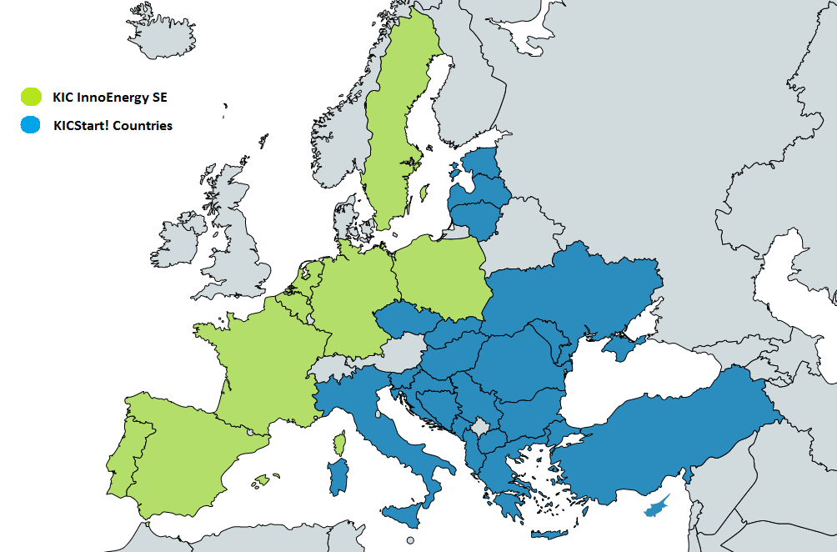
InnoEnergy Hub Partnership Proposal Template
InnoEnergy countries
RIS countries

Executive Summary
Please provide a summary of the information detailed throughout this partnership proposal.

Thematic alignment
Please describe your track record and engagement in energy, local entrepreneurial and innovation ecosystem. Any potential links with the InnoEnergy Business Model. Please present here:
- Your experts in Energy, Engineering or Chemistry with experience in energy market (incl. Energy or GHG related R&D projects);
- Previous experience with Energy projects;
- Other relevant experience with Energy or Green House Gases.

Capacity
Please describe your past experience, resources and potential to operate the InnoEnergy Hub and local operations. We are interested in your unique set of team members, leaders of proposed activities and the skills and resources to have to play a major role in the local ecosystem. Please describe the services your provide today to your ecosystem, your experience and capabilities. Please underline members with expertise in sales, marketing or consultancy and supporting stuff;

Commitment
Please provide a justification for your involvement, the sustainability of the budget plan you propose and the opportunities enabled through the cooperation in your ecosystem. Please present here:
- Operational plan for 12 months with budget specification and resources needed (max. InnoEnergy involvement is up to 140k EUR for the whole duration);
- Development Strategy 2022+ – development strategy of the Hub and the surrounding operations, complementary to the Hub activities.

