InnoEnergy Hub Partnership Proposal Template
Instructions

The partnership proposal template is designed to assist in prompting and structuring partnership proposals prior to submission for analysis and decision-making.

In proposing your partnership, your overall goal should be to provide a persuasive argument for the partnership’s implementation. Convey the merits of your partnership from the perspective of your unit and its place within the organization and in the attachments please provide all necessary documents to prove the information provided.

Once submitted, your partnership proposal will be analyzed and considered amongst other proposals throughout the network in a process designed to successfully prioritize, schedule, and coordinate partnership to maximize their effect. The goal will be to produce the greatest overall benefit to the community with consideration of the limited resources.

InnoEnergy Hub Partnership Proposal Template
Summary

Working Title
Participants

Type of entity
Activity Type

Primary Contact | Name
 | Phone
 | Email
Backup Contact | Name
 | Phone
 | Email

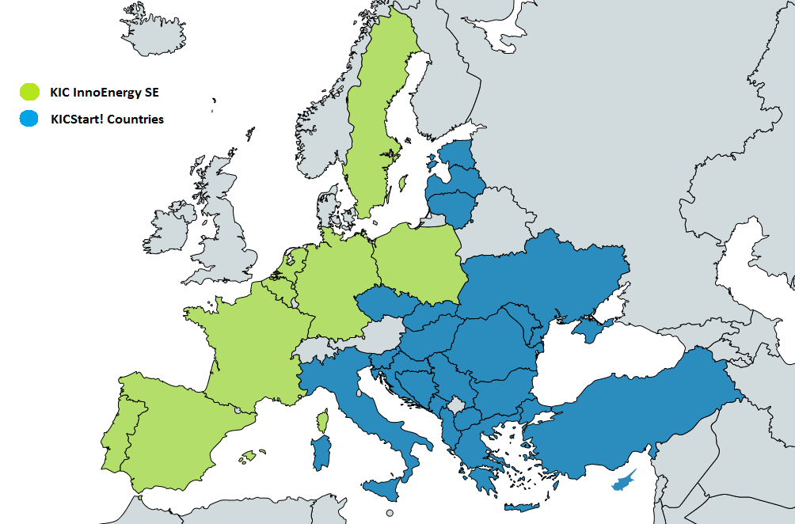
InnoEnergy Hub Partnership Proposal Template
InnoEnergy countries
RIS countries

Executive Summary
Please provide a summary of the information detailed throughout this partnership proposal.

Statement of Need
Discuss the needs or opportunities to be addressed by this partnership. In your discussion, describe and position these needs or opportunities within the context of your organizational/country environment. Internal factors, as well as external ones, should be considered.

Thematic alignment
Please describe your track record and engagement in energy, local entrepreneurial and innovation ecosystem. Any potential links with the InnoEnergy Business Model. Please present here:
- Your experts in Energy, Engineering or Chemistry with experience in energy market (incl. Energy or GHG related R&D projects);
- Previous experience with Energy projects;
- Other relevant experience with Energy or Green House Gases.

Capacity
Please describe your past experience, resources and potential to operate the InnoEnergy Hub and local operations. We are interested in your unique set of team members, leaders of proposed activities and the skills and resources to have to play a major role in the local ecosystem. Please describe the services your provide today to your ecosystem, your experience and capabilities. Please present here:
- Team – please underline members with startup incubation and acceleration experience; coaches or mentors, experts in sales, marketing or consultancy and supporting stuff;
- Office space (size and location) and access to incubator space;
- Network of investors or institutions dealing innovations, startups or energy;
- Other incubation, acceleration and investment experience.

Commitment
Please provide a justification for your involvement, the sustainability of the budget plan you propose and the opportunities enabled through the cooperation in your ecosystem. Please present here:
- Operational plan for 18 months with budget specification and resources needed (max. InnoEnergy involvement is 140k EUR for the whole duration);
- Development Strategy 2020+ – development strategy of the Hub and the surrounding operations, complementary to the Hub activities for minimum three years.

Relations with national/regional authorities
Please describe the potential links you have in the local ecosystem and the position you can obtain thanks to the Power Alliance Partnership as in it as a role model. Synergies with other regional activities and local funding (national and EU Structural Funds) are highly encouraged. Please present here your links with:
- Public local/regional authorities
- Public-Private organisations or NGO supporting innovations, investment or development activities in the region
- Reputed major– public or private owned - but for-profit companies.

Sales Strategy
Please provide a justification for your involvement, the sustainability of the budget plan you propose and the opportunities enabled through the cooperation in your ecosystem. Please present here:
- Operational plan for 18 months with budget specification and resources needed (max. InnoEnergy involvement is 140k EUR for the whole duration);
- Development Strategy 2020+ – development strategy of the Hub and the surrounding operations, complementary to the Hub activities for minimum three years.

